**Precondition**

The process of checking the validity of data, processing it and adding it to the database (DB) works correctly. The task relates directly to the implementation of notifications when the user interacts with the form.

**Title**

Implementation of notifications when the user is working with the form.

**Description**

It is necessary to develop hints, pop-up notifications for users when working with the form.

**Business case**

Correct and understandable interaction between the system and users.

**Description of to-do**

The "Newsletter subscription" form contains:

* Input «Name»,
* Input «Email» (required),
* Button «Submit».

The required field "Email" must be marked with "*".

The general view of the form is shown in Image 1.

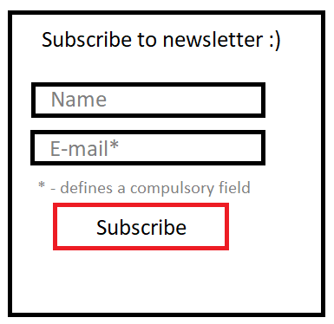

Image 1

When trying to send an empty form, a message should be displayed next to the "Email" field: "The field must be filled in".

If you enter any of the fields incorrectly, a message should be displayed next to this field by type: "The field is filled in incorrectly. The field must contain {a description of the correct data required for this field of characters}".

For example, if the "Name" field must consist of at least 3 characters and contain only letters of the Latin alphabet, then when entering data that does not meet these conditions, the following message will be displayed: "The field is filled in incorrectly. The field must contain at least 3 characters, only Latin letters can be entered."

For example, if the "Email" field must consist of at least 6 characters, contain letters of the Latin alphabet (a-z), numbers (0-9), dots (".") (it is not allowed several times in a row), the sign ("@"). All other special characters are prohibited. When entering data that does not meet these conditions, the following message will be displayed: "The field is filled in incorrectly. The field must contain at least 6 characters, it is allowed to enter only letters of the Latin alphabet, the sign "@" and "." (exception: several in a row)."

Since the e-mail must be unique, when trying to subscribe to the newsletter again by entering an existing e-mail in the DB, the message "The user with this E-mail has already subscribed to the newsletter" should be displayed. This message should be displayed above the "Subscribe" button.

If the field is filled in incorrectly and the user clicked the "Subscribe" button, then a message about incorrect data should be displayed above the corresponding field, while the data of this field entered by the user is not cleared.

If the fields are filled with correct data, the e-mail is unique and is not present in the DB, after clicking the "Subscribe" button, the message "You have successfully subscribed to the newsletter" should be displayed above it.